Hankscraft H20 Products RevV4
Multifunctional Control Valve
72605

Instruction Manual

Please read this manual in detail prior to installation and use.
Retain this manual for future reference.

0WRX.466.001

Record the following information for future reference.
Softener System Configuration
Tank Dia.: in Height: in Resin Volume: gr. Brine Tank Capacity: gal Raw Water Hardness: ppm
Water Pressure: PSI Serial Number:
DLFC : Injector: BLFC:
Water source: Well □ Filtered Well □Municipal □ Other
Default Parameters
Parameter | Unit | Default | Actual Value
Language | / | English
Program Type | / | Interlock
Regeneration Sequence | / | 1
Control Mode A-01/02/03/04/05/06 | / | A-01
Water Treatment Capacity | gal | 12000
Operation Days(A-06) | D | 03
Regeneration Start-up Time | / | 2:00
Backwash Time | min | 10
Secondary Backwash | min | 5
Brine & Slow Rinse Time | min | 60
Fast Rinse Time | min:sec | 05:00
Feed Water Hardness(A-03/04) | ppm | 171
Total Hardness(A-03/04) | gr | 28k
Fast Rinse Time | min | 10
Alarm Days | D | 500
Interval Regeneration Days | D | 30
Output Mode b-01(02) | / | b-01
- Hankscraft H20 Products recommends the use of #1 DLFC and a #9 injector for the standard configuration of a 9x48 resin tank & 1 cu/ft. of resin.

Notice…………………………………………………………………………5
2. Characteristics…………………………………………………………. 6-8
3. Temperatures and Ratings……………………………………….…...…..9
4. RevV4 Dimensions………………………………….……………….…….9
5. Installation………………………………………………………...…..10-12
A. Preparation…………………………………………………….……..10
B. Location…………………………………………………………..…..10
C. Plumbing and Mechanical Setup………………………………..……10
I. Installing the Control Valve…………………………...……..…..10
II. Bypass Installation……………………………………….……..11
III. Plumbing Connections…………………………….….………..11
IV. Drainline Installation………………………………….……….12
V. Brineline Connection…………………………………..……….12
6. Programming Instructions……………………………………………….13
A. Unlocking the Keypad………………………………………..……..13
B. Enter Key…………………..……………………………….………..13
C. Manual Regen Esc. Key
7. Default Settings……………..…………………………………..………..14
A. Min/Max Parameters…………………………………………….14-15
B. Display Processes……………………………………………………15
C. Corresponding Control Mode……………………………………….16
8. Application………………………………………………………………..17
A. Softener Flow Chart…………………………………………………17
B. Mainboard Functions……………………………………………..17-18
C. Signal Output Connector……………………………………….……19
I. Solenoid Valve on Outlet………………………………….…….19
II. Solenoid Valve on Inlet……………………………………..19-20
III. Liquid Level Controller with Inlet Pump…………………..20-21
IV. Liquid Level Switch in Water Tank……………………..……..21
V. Inlet Booster Pump…………………………………….……21-22
D. Interlock…………………………………………………….……….22
E. Alternating Interlock……………………………………….………..22
F. Remote Handling Connector……………………………….………..23
G. Interlock Options………………………………………………….23-24
H. Using One Flow Meter with Interlock………………………….…….24
9. System Configurations.............................................................................24-25
A. Product Sizing………………………………………………..……….24
B. Injector Table…………………………………………………….……25
C. Injector and DLFC Table………………………………………….…..25
10. Programming Modes…………………………………………………..…26
A. User Available Programming………………………………………….26
B. Advanced Programming……………………………………………….27
11. Trial Run…………………………………………………………………..28
12. Trouble Shooting Control Valve………………………………………29-31
13. Trouble Shooting Electronics…………………………………………..…32
14. Assembly Drawings………………………………………….…………33-36

Notice
- Consult your water treatment professional prior to installation.
- In the event of major plumbing or electrical work requirements it is recommended to contact a certified professional. Follow local, state, and municipal guidelines.
- Do not use the control valve with water that is unsafe or unknown quality.
- Regular interval monitoring of the water quality and work environment is recommended to insure proper operation of the valve and system.
- Quality resin and proper capacity is required for accurate operation.
- Sodium used in the water softening process should be considered part of your overall dietary salt intake.
- Ensure that there is solid salt in the brine tank at all times. Hankscraft H20 Products recommends 99.5% pure salt. The use of solar salt and small particulate salts is not recommended.
- Do not put the valve near a heat source, high humidity, corrosiveness, intense magnetic field or vibrational environments.
- Do not use the brine tube, injector body, or other connectors on the RevV4 valve as a handle to carry the system.
- Please use this product with temperatures of 40-125°F and water pressures of 20psi – 120psi. Failure to use this product within the described conditions voids the warranty.
- If the water pressure exceeds 120psi, a pressure reducing valve must be installed before the water inlet. If the water pressure is under 21psi, a booster pump must be installed before the water inlet.
- Replacement parts for the RevV4 valve should only be purchased through Hankscraft H20 Products resellers. Electrical components such as transformers are specific to the RevV4 valve from Hankscraft.

1. Applications
Residential softening system, Ion exchange equipment, Boiler softening water system, RO pretreatment and filtration.

2.Characteristics
- Mechanical Components
The RevV4 uses hermetically sealed ceramic discs which are corrosion and abrasion resistance for reliable operation. Up-flow regeneration, no hard water bypass, and hard water bypass options.
- Excellent Flow Rate
Flow Rate is 21gpm @ 15psi drop.
- The RevV4 Holds Usage Information
Maximum flow rate, total days of use, # of regenerations, error messages, and a gallon countdown clock until regeneration.
- Manual Advance
Pushing the manual button at any time results in a manual regeneration. Each phase can be advanced as well.
- Extended Power Outage Indication
If outage lasts for 3 days or more, the time of day indicator 12:12 will flash as a reminder to reset the time of day. All other set parameters will not need to be reset. The RevV4 valve will continue to process from the point of the power outage.
- Three Regeneration Sequences to Choose From
Three regeneration sequences to choose from based on individual needs and circumstances.
- Lockout Function
Within 1 minute of idle use, the button lock function will engage and the padlock icon indicates the keypad is locked. To resume programming or operations press and hold the “”and“” buttons for 3 seconds.

- LCD Display Screen
The LCD is backlit and lights up when the keypad is used. Avoid direct sunlight.
- Regeneration Modes.
Mode | Name | Instruction
A-01 | Meter Delayed | Regenerates when the capacity reaches Zero (0) and the preset time of regeneration is reached. Usually 2:00am
A-02 | Meter Immediate | Regenerates immediately once capacity is reached, regardless of the time of day.
A-03 | Intelligent Meter Delayed | The same delay function as A-01 but the capacity is set by input of the Resin Volume and Feed Water Hardness. The RevV4 calculates the gallons before regeneration.
A-04 | Intelligent Meter Immediate | The same delay function as A-02 but the capacity is set by inputting the Resin Volume and Feed Water Hardness. The Control valve calculates the gallons before regeneration.
A-05 | Surplus Water Comparison | This mode employs A-03 functions with the added comparison of the previous 7 day usage. The valve knows the remaining capacity and chooses the day to regenerate.
A-06 | Time Type by Day | Time clock mode. Used in filter configurations or for applications which require regular interval regeneration.
- Signal Output
The output signal connector is designed to drive several different types of electrical devices. (Refer to Figure from Figure3-1 to Figure 3-7).

The two types of output modes are b-01 and b-02. (see page 18-19)
b-01 switches the signal at the start of a regeneration and shuts off at the end of a regeneration.
b-02 switches the signal at the intervals shown below and in service. (Regeneration sequence 1 is used in this example).
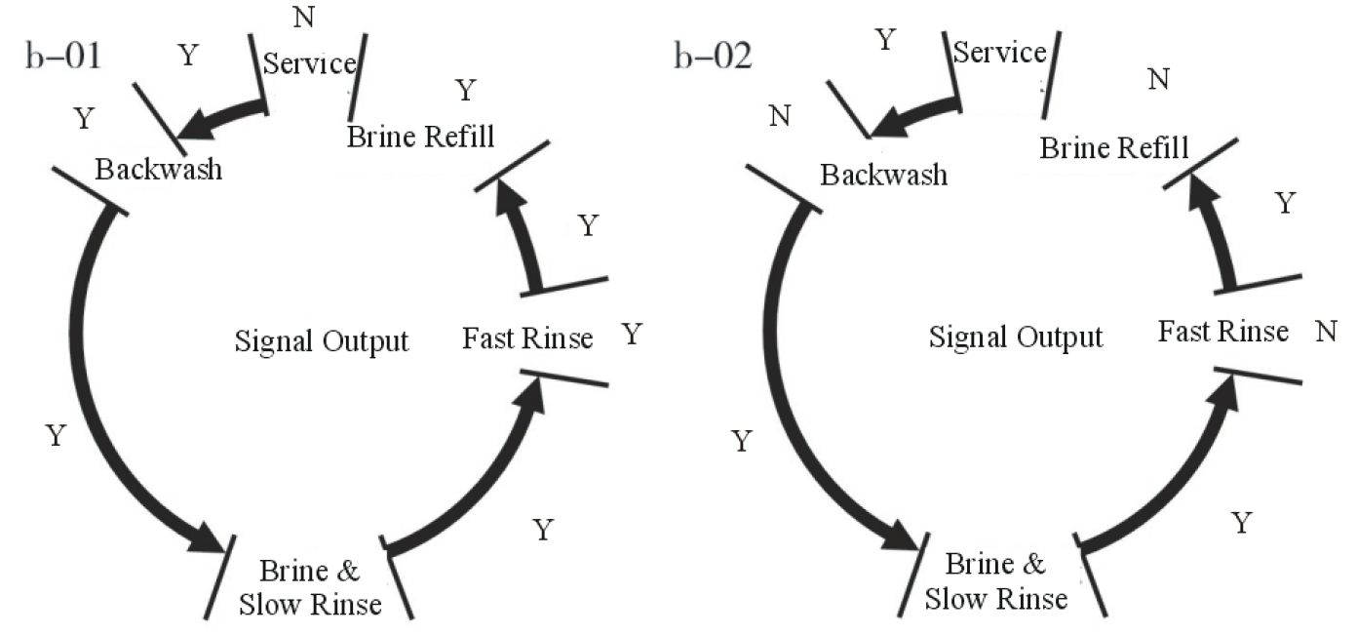
- Interlock Function
When the RevV4 valve is programmed as “Interlock” and the cables are connected between the valves, only one valve will regenerate at a time. The other valves connected in either series or parallel will remain in service. This application insures water passes through the remaining valves while one is regenerating. (Refer to Figure 3-8)
- Alternate Interlock
The RevV4 can be set with alternating interlock where one control valve is in service and one in standby. A Hankscraft H20 Products 3-way ball valve is used to divert the water supply appropriately. (Refer to Figure 3-9)
- Remote Handling Connector
This connection is designed to receive an external signal, from a PLC, computer, or other device. The PLC controls the sequence of regeneration within a system of multiple control valves.
- Maximum Interval Regeneration
This setting allows the user to set a maximum number of days between regenerations.
- Flexible Parameters
Each phase of regeneration is adjustable in respect to its individual time.

3. Temperatures and Ratings
The RevV4 valve should operate within the following conditions
Item |  | Requirement
Working Conditions | Working pressure | 20psi～120psi
Working Conditions | Water temperature | 40 °F～125 °F
Working Environment | Environment temperature | 40 °F～125 °F
Working Environment | Relative humidity | ≤95%
Working Environment | Power source | AC100～240V/50～60Hz
Inlet Water Quality | Water turbidity | Up-flow regeneration＜2FTU
Inlet Water Quality | Water hardness | Refer to sizing chart.
Inlet Water Quality | Free chlorine | ＜0.1ppm
Inlet Water Quality | Iron²⁺ | ＜0.3ppm
4. RevV4 Dimensions Dimensions for reference only.
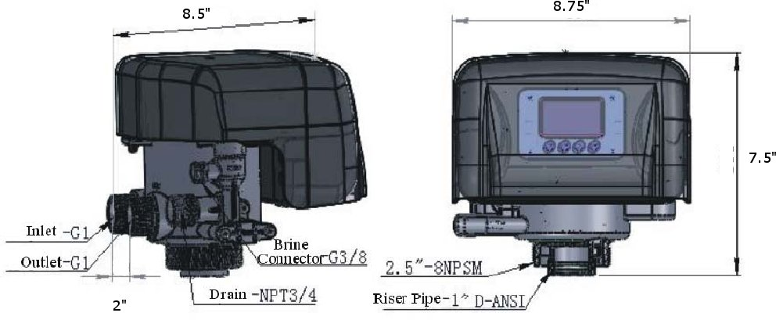
Model | Length  max | Width  max | Height  max |  |  | Regeneration  Mode
RevV4 | 8.5” | 8.75” | 7.5” |  |  | Up-flow

Transformer Output: DC12V/2.0A

5. Installation
      - Preparation
Before installation, read through this manual thoroughly. Then obtain all materials and tools needed for installation.
The installation of Hankscraft products, and related equipment such as plumbing and electrical, should be performed by an accredited professional to ensure the product and building codes are met.
      - Location
- The filter or softener should be located close to a floor drain.
- Ensure the unit is installed with enough space for operation and maintenance.
- Brine tank should be installed close to the RevV4 control valve.
- The unit should be installed away from heat sources.
- The installation surface should be clean and level.
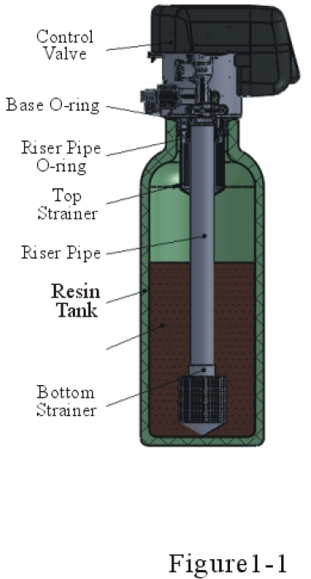
- Install the unit in an environment which minimizes consumer impact in the event of malfunction.
      - Plumbing and Mechanical Setup
- Valve Installation.
- As Figure 1-1 shows; select a 32mm or 1.25” riser pipe, glue the riser pipe to the bottom strainer and put it in the center of the mineral tank. Cut off the excess tubing as described in the note below.
- Fill the mineral tank with resin if not purchased as a complete system from Hankscraft H20 Products. Quantity is relative to desired capacity and tank size. Plug the riser tube prior to filling with resin.
- Install the top distributor with a twist and lock action to center hub of the RevV4. Also acts as a pilot for the riser pipe.

- Lubricate the center O-ring of the RevV4 and place onto tank with the distributor tube inserted down the middle. Rotate clockwise to fix onto the resin tank.
Note:
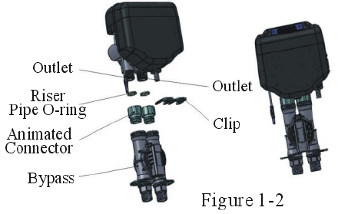
● The length of riser tube should not be higher than .312” or lower than .437” in relation to the top of the resin tank. The edges of the tube should not be sharp to avoid damage to the seal inside the RevV4 valve.
● Keep foreign material out of the resin tank.
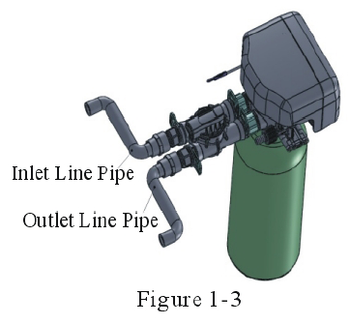
● Insure the O-ring that seals around the neck of the pressure tank is installed.

- Bypass Installation
As Figure 1-2 shows; install the seals into the ring nut. Screw the ring nut into water inlet/outlet. Insert the bypass valve and attach the quick disconnects.
- Plumbing Connections
As Figure1-3 shows; connect inlet pipe with inlet connector of bypass via 1” NPT female connector. Connect outlet pipe with outlet pipe of bypass via 1” NPT female connector.

- Drainline Installation
Install the DLFC inside the drain barb connector of the RevV4.
As Figure 1-4 shows; insert drain line with an air gap to the floor drain.
- Insert O-ring into O-ring slot of the drain barb.
- Insert barb onto the RevV4 and tighten locking collar.
- Screw drain hose connector into the drain barb.

- Brineline Connection
- As Figure1-5 shows; slide 3/8″ brine tube into hose connector.
- Insert the filter net into the tube.
- Insert the feral into the end of brine tube.
- Tighten brine draw hose connector onto the RevV4 valve.
- Connect the other end of brine tube to the brine tank. (We recommend the Hankscraft H20 products brine tank with safety float.)

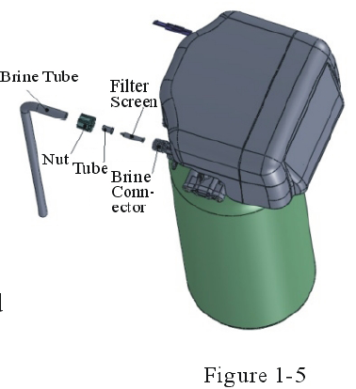
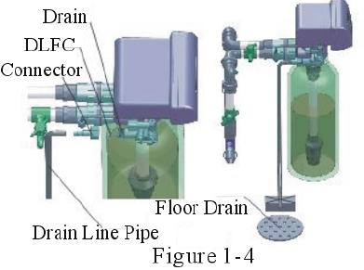

6. Programing Instructions
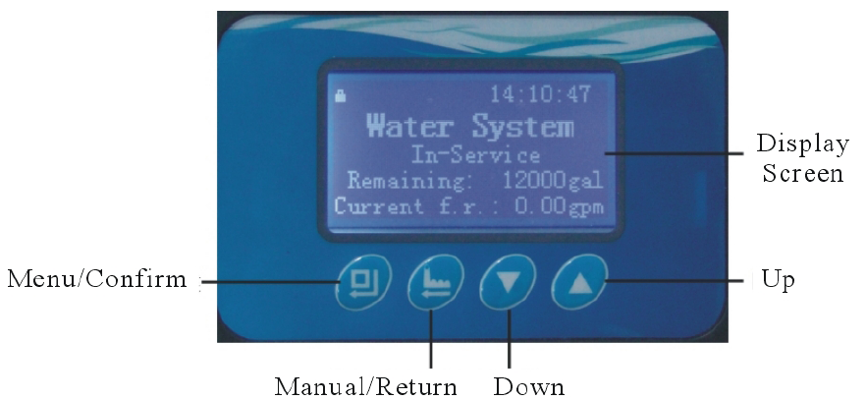
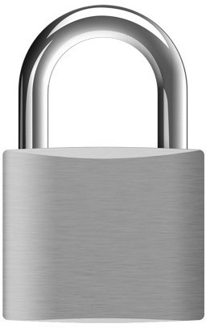
- Unlocking the Keypad
    - icon indicates the buttons are locked within 1 minute of idle use.
    - To unlock press and hold and for 3 seconds until the icon is off.
- Enter Key
    - Press button to enter the basic programming mode.
    - Use or to scroll through the various basic programming options.
    - Press button to modify highlighted option. Press the or and adjust values.
    - Press after the value is set and the program returns to the main menu.
- Manual Regen/Esc. Key
      - Press again at any phase during manual regeneration to advance to the next phase.
      - Press while changing program options. This exits to the home screen without modifying the current option open.

Default Settings
- Min/Max Parameters
Setting Entry | Parameter Setting | Factory Default | Instruction
Time of Day | 00:00～23:59 | Random | 24 hours type
Water Treatment Capacity | 0～99999gal | 12000gal | “A-01/02/05” mode
Regeneration Time | 00:00～23:59 | 02：00 | 24 hours type
Backwash Time | 0～99min | 10min | /
Second Backwash Time | 0～99min | 5min | Regen Cycle 2”
Brine Time | 0～99min | 60min
Brine Refill Time | 0～99:59min | 5:00min | Time set can be accurate to second
Fast Rinse Time | 0～99min | 10min | /
Raw Water Hardness | 10～999ppm | 171ppm | “A-03/04” mode
Total Hardness | 10K～9999gpg | 28gpg | “A-03/04” mode
Maximum Interval Regeneration Days | 0～40Day | 30 Day | All modes except “A-06”
Service Day | 0～99Day | 3Day | “A-06”mode
Daily Water Usage Past Seven Days | 1. The RevV4 records the daily usage, maximum flow rate for seven days and the # of regeneration times.  2. Selecting “data reset” will clear the recorded usage. |  | Applicable for all modes except “A-06”
Maximum Flow Rate of Past Seven Days |  |  | Applicable for all modes except “A-06”
Regeneration Times |  |  | Applicable for all modes except “A-06”

Setting Entry | Parameter Setting | Default | Instruction
Language Set | English | English | N/A for USA
On-line Program | Interlock = 1 in service 1 in standby | Interlock | For single valve default use interlock
Regeneration Cycle (sequence) | Choose 1, 2 or 3 | 1 | Adjustable sequences
Data Reset | Close/Open | Close | “Close” = Data Saved  “Open” = Reset Data
Regeneration Control Mode | A-01/02/03/04/05/06 | A-01 | Refer to page 7 table
Alarm Day | 50～700 Days | 500 | Counts down one day at a time at midnight.
- Display Processes
12:12:30
Service
Capacity remain：900 gal
Instantaneous Flow R：15gpm

12:12:30
Water Supplying
Need to Service 3 days
Regen Time：02:00

12:12:30
Water Supply Capacity Remain：900 gal
Regen Time：02:00

Figure A Figure B Figure C
13:12:30
Backwash……
6:00(Min:Sec)

14:12:30
Brine & Slow rinse…
60:00(Min:Sec)

14:32:30
Fast rinse ……
6:00(Min:Sec)

Figure D Figure E Figure F
14:32:30
Brine Refi……
5:00(Min:Sec)

Motor Runing……

14:32:30
Sec Time Backwash…
5:00(Min:Sec)

Figure G Figure H Figure J

- Corresponding Control Mode

- Figure A represents service status within mode A-02/04. Figure A/B represents control mode A-01/03/05, the. When the valve is in mode A-06, reference Figure C.

- In backwash status, reference Figure D. In brine & slow rinse status, reference Figure E. In fast rinse status, reference Figure F. In brine refill reference, Figure G.

- When two valves are connected with the interlock cable and both valves have reached maximum capacity the valve displays “system supply water temporary”. When both valves are set to alternate interlock, then one valve is in service and the other is in standby, the waiting valve screen displays “system wait supplying water”.

- If the time of day icon“” flashes continuously, this indicates an extended power outage. The current time of day needs to be re-set.

- If the valve experiences a malfunction the valve will display E-1. Disconnect the power and re-apply.

- Working process for regeneration sequences.
1: service→Backwash→Brine→Fast rinse→Brine refill→Service

2: Service→Backwash→Brine→Second time back wash→Fast rinse→Brine→Service

3: Service→Brine refill→Backwash→Brine→Fast rinse→Service

8. Application

A. Softener Flow Chart

Backwash

Start Service
Up-flow Regeneration

Brine

Slow Rinse
Brine Refill

Fast Rinse

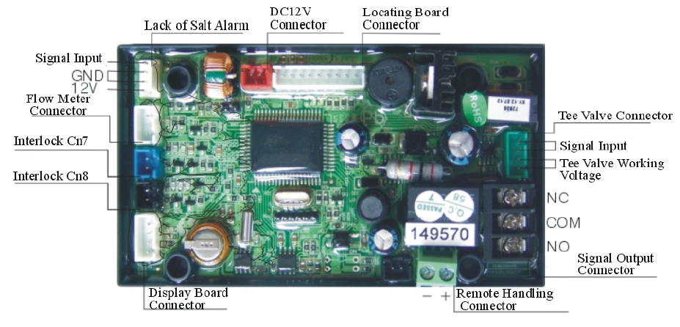
B. Main Board Functions

Function | Application | Explanation
Signal Output Connector b-01 | Outlet solenoid valve | Optional to prevent water flow from outlet or controlling a liquid level holding tank.
Signal Output Connector b-01 | Inlet pump | Increase pressure for regeneration or backwash.  Use a liquid level controller to control inlet pump.
Signal Output Connector b-02 | Inlet solenoid valve or inlet pump | When inlet pressure is high, a solenoid shut off can be used to protect the valve during regen.
3-Way Ball Valve Drive | Motorized 3 way ball valve | With alternating interlock set the ball valve actuates to supply water to one valve while another is on standby.
Interlock Connector | Used for a series of valves | Only one valve in a series can regen at a time.
Remote Handling Connector | Accepts input for regeneration from external source | A PLC or computer is allowed to dictate regen functions for the valve

C. Signal Output Connector
              - Solenoid Valve on Outlet (set b-01)
Figure 3-1 shows how to connect a solenoid valve for the purpose of shutoff during regeneration.

Function: Valve is normally open. When the RevV4 is in backwash, there is no signal output. So the solenoid valve is closed, and no water flows through the RevV4 to the holding tank.
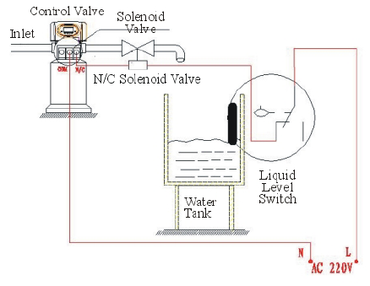
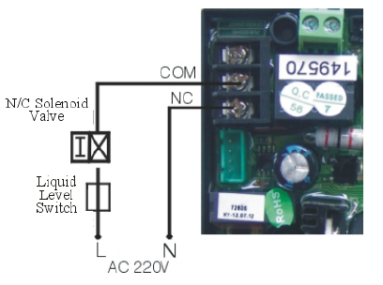

Figure 3-1 Solenoid Valve on Outlet

              - Solenoid Valve on Inlet ( set b-02)
Function: When inlet pressure exceeds 125 psi, install a solenoid valve on the inlet to switch off the flow to the valve during switching.
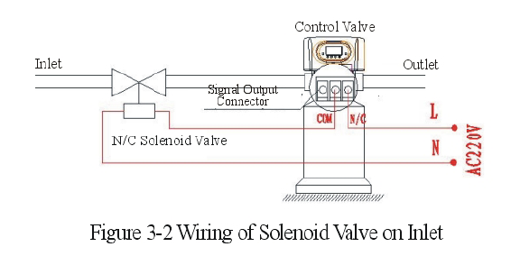

Function: When the RevV4 is in Service, Backwash, Brine& Slow Rinse, Brine Refill and Fast Rinse, the solenoid valve is open. When the RevV4 is switching, the solenoid valve is closed, and no water flows through the RevV4. Also prevents water hammering in high psi applications.
Note if employing a series of RevV4 valves with a solenoid Figure 3-3 depicts the wiring connections.
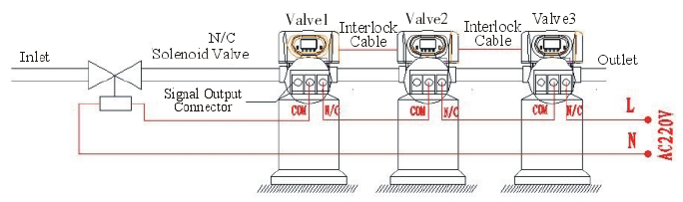
Figure 3-3 Wiring of Solenoid Valve on Inlet
              - Liquid Level Controller with Inlet Pump (two-phase motor)( set b-01)
Function: For a well system and holding tank, the RevV4 can act as a relay for the booster pump. Refer to Figure 3-4 for wiring.
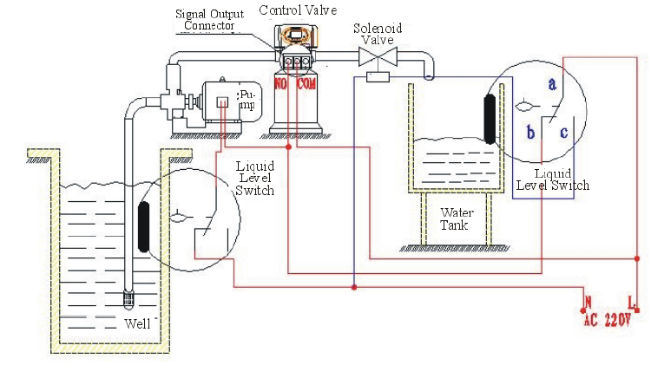
Figure 3-4 Wiring of Liquid Level Controller on the Inlet

Function: When the RevV4 is in service, and the water level in the tank is low, the pump starts up. If the water tank has enough water, the switch for the liquid level controller is closed and the pump is off.
When the RevV4 is in regeneration, the inlet always requires water. A safety switch should be installed in the holding tank so the pump does not go dry.
              - Liquid Level Switch in Water Tank Controls Inlet Pump (three-phase,figure3-5) (set b-01)
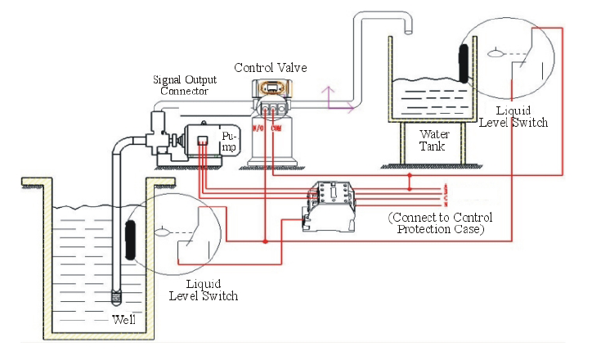
Figure 3-5 Wiring of Liquid Level Switch in the Holding Tank with the Pump on the Inlet.
              - Inlet Booster Pump (set b-01 or b-02) (see page 7,18)
Function: If inlet water pressure is less than 20 psi, install a pump on the inlet side of the RevV4; usually set for control mode b-01. When the RevV4 valve is in regeneration, the booster pump is open and active. If the booster pump current is greater then 5A, an external contact is required. Refer to Figure 3-7

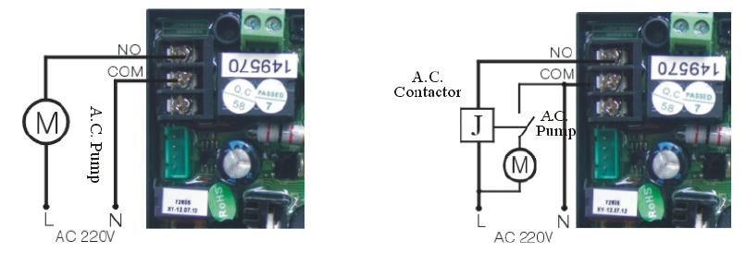
Figure 3-6 Schematic of output to a pump < 5A.
Figure 3-7 Schematic of output to a pump > 5A. Incorporates relay.

      - Interlock
Function: With parallel installation only one valve regenerates at a time. Figure 3-8
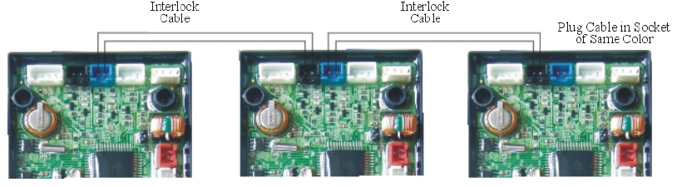 Figure 3-8 Interlocking a Network of Valves.

Note: Use Interlock cable to connect CN8 to CN7 to the next RevV4 in the series. If one interlock cable is disconnected, the system is divided into two individual systems.
      - Alternating Interlock
Function: One valve will always be in service. Refer to Figure 3-9
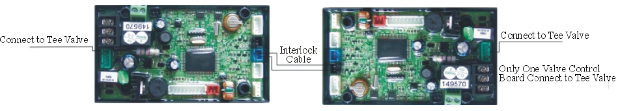
Figure 3-9 Wiring for Alternating Interlock
      - Remote Handling Connector
Function: Online TDS meter monitor, PLC or PC controls the regeneration time. When the controller receives a contact closure from above instruments, regeneration begins. Refers to Figure 3-10:

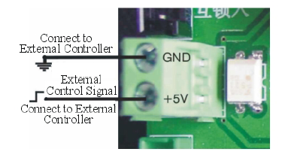
Figure 3-10 Remote Handling Schematic.

G. Interlock Options
Function: 2 or more valves interlocked connecting in one system. Refer to Figure 3-11 and 3-12. 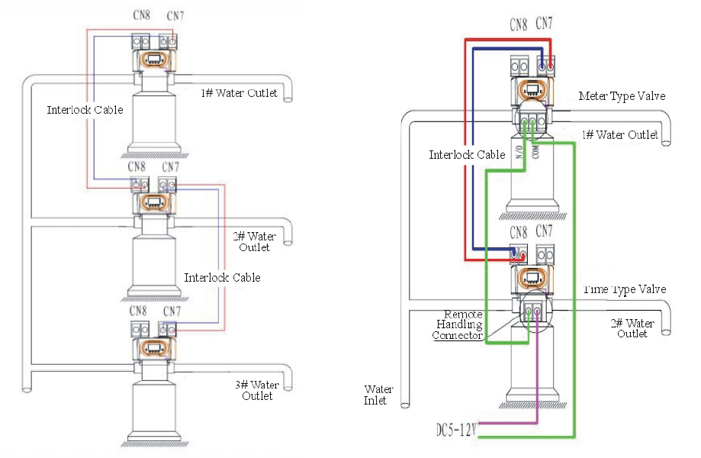
Figure 3-11 All in Service. Singular Regeneration.
Figure 3-12 Remote Handling Sequentially Set.

H. Using One Flow Meter with Interlock
Function: This application is for 2 or more RevV4’s in a system, all in service, with one flow meter for the entire system. For Time Clock mode, the regeneration time should be set and adjusted to the Max; if a volume set valve is part of the system, connect its signal output connector with the remote handling connector of the Time Clock set valve. This function allows continuous water and simultaneous and non overlapping regenerations. Refer to Figure 3-12:

9. System Configurations
A. Product Sizing
Product configuration with tank, resin volume, brine tank and injector
Tank Size inches | Resin Volume（cu/ft） | Flow Rate (gpm） | Brine Tank Size mm | The Minimum Salt Consumption per Regeneration（lbs） | Injector Model
8×40 | .5 | 2.201 | 10×20 | 6 | 6302
9×48 | 1 | 3.081 | 15×32 | 9 | 6303
10×54 | 1.5 | 5.28 | 15×32 | 12 | 6305
12×65 | 2 | 8.146 | 18×37 | 20 | 6306
14×65 | 3.5 | 11 | 20×42 | 33 | 6308
16×65 | 4.5 | 15.407 | 20×42 | 40 | 6309
18×65 | 5.5 | 19.809 | 20×42 | 50 | 6310
Note: The flow rate calculation is based on linear velocity 22 gpm.

B. Injector Table
Inlet Pressure | Draw Rate（gpm）
PSI | 6301  Coffee | 6302  Pink | 6303  Yellow | 6304  Blue | 6305  White | 6306  Black | 6307  Purple | 6308  Red | 6309  Green | 6310  Orange
21.75 | .31 | .4 | .59 | .76 | .85 | 1.03 | 1.08 | 1.16 | 1.47 | 1.5
29 | .36 | .46 | .69 | .87 | 1 | 1.18 | 1.23 | 1.37 | 1.75 | 1.8
36.25 | .42 | .51 | .76 | .96 | 1.11 | 1.31 | 1.39 | 1.64 | 1.93 | 2.02
45.5 | .45 | .56 | .84 | 1.05 | 1.21 | 1.37 | 1.52 | 1.78 | 2.03 | 2.27
50.76 | .49 | .6 | .89 | 1.13 | 1.33 | 1.48 | 1.62 | 1.91 | 2.23 | 2.53
58 | .65 | .63 | .95 | 1.22 | 1.41 | 1.51 | 1.88 | 1.99 | 2.35 | 2.62
C. Injectors and Drain Line Flow Control
Tank Dia. mm | Injector  Model | Injector  Color | Draw Rate | Slow Rinse | Brine Refill | DLFC | Backwash / Fast Rinse
Tank Dia. mm | Injector  Model | Injector  Color | gpm | gpm | gpm | DLFC | gpm
150 | 6301 | Coffee | .45 | .27 | .62 | 1# | 1.1
175 | 6302 | Pink | .56 | .34 | .68 | 1# | 1.27
200 | 6303 | Yellow | .84 | .44 | .75 | 2# | 1.85
225 | 6304 | Blue | 1.05 | .65 | .77 | 2# | 1.85
250 | 6305 | White | 1.21 | .73 | .78 | 3# | 3.04
300 | 6306 | Black | 1.37 | .83 | .77 | 3# | 3.04
325 | 6307 | Purple | 1.52 | .94 | .79 | 4# | 6.02
350 | 6308 | Red | 1.78 | 1.1 | .79 | 4# | 6.02
400 | 6309 | Green | 2.03 | 1.33 | .82 | 5# | 7
450 | 6310 | Orange | 2.27 | 1.66 | .82 | 5# | 7
Note: The above tables are reference only.

10. Programming Modes

- User Available Programming
When the icon is on, press and hold both andfor 5 seconds to unlock the keypad; then press the to enter the main menu; pressor highlight each option. Press the key to accept changes. (Press to exit back to service status）
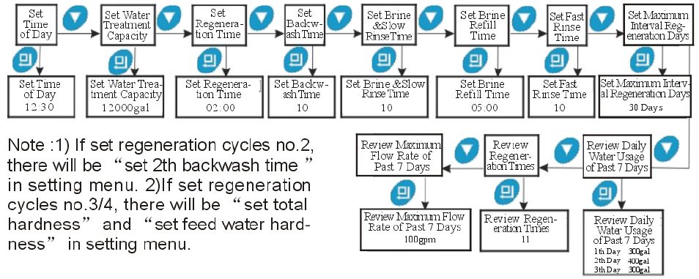

- Advanced Programming
Plug the RevV4 in and pressin sequence to enter into the advanced setting. Pressor, to select the menu item to be changed (Press to return to the previous menu).
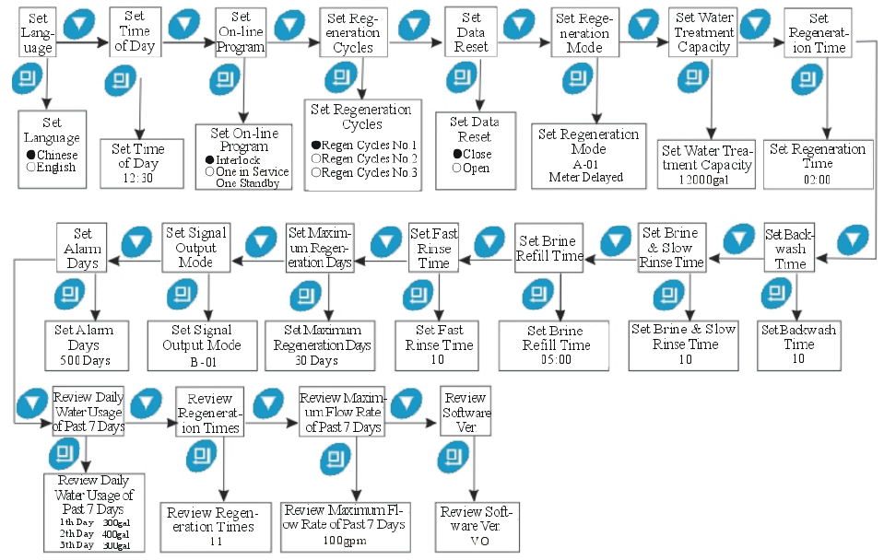

11. Trial Run
After installing the RevV4 valve, please conduct the trail run as follows:
  - Before running the RevV4 for the first time turn the bypass off. Turn the water source on at the inlet to the house. Disconnect the bypass from the RevV4. Remove the meter impeller from the bypass. Put a container under the bypass and turn the bypass on to remove any foreign material out of the water lines that might have been caused during the plumbing installation. Turn the bypass off, reinstall the meter impeller and re-connect the valve.
  - Fill the brine tank with the planned amount of water (usually 3 gallons for a 1 cu/ft. system) and adjust the brine shutoff float accordingly. Then add solid salt to the tank and allow to dissolve. Usually a 40lb bag minimum.
  - Switch on power. Open a water line and let water flow until water runs clear. Press and go in the Backwash position; which lets air out of the drain line. It will take 8-10 minutes to purge the system.
  - Press, to advance from Backwash to Brine & Slow Rinse. Verify the air check valve is closed. When control valve finishes this cycle, the valve moves to slow rinse. Brine and Slow rinse should take 60-65minutes.
  - Press, to advance to Fast Rinse position.
  - Press, to advance to Brine refill position. Add more salt to the brine tank so that the brine tank is at least 50% full of salt.
  - Press, returns the RevV4 valve to Service Status.
  - Take a water sample from the outlet to verify and test for calcium reduction.

Note: When the control valve enters into the regeneration mode, the valve will continue the process automatically according to the settings. If you want to skip or advance to another phase press .
12. Trouble-Shooting Control Valve
Issue |  | Cause | Solution
1. Softener fails to regenerate. |  | A. Electrical service to unit has been interrupted.  B. Regeneration cycles set incorrectly.  C. Controller is defective  D. Motor failure. | A. Check for consistent electrical service  B. Reset regeneration cycles.  C. Replace controller.  D. Replace motor.
2. Regeneration time is not correct. |  | A. Time of Day not set correctly.  B. Power failure over 3 days. | Check program and reset time of day.
3. Hard water. |  | A. Bypass valve is open or leaking.  B. No salt in brine tank.  C. Injector plugged.  D. Insufficient water flowing into brine tank.  E. Leak at O-ring on riser pipe.  F. Internal valve leak.  G. Regeneration cycles not correct.  H. Shortage of resin.  I. Bad quality of feed water or turbine blocked. | A. Close or repair bypass valve.  B. Add salt to brine tank and maintain salt level above water level.  C. Change or clean injector.  D. Check brine tank refill time.  E. Make sure riser pipe is not cracked. Check o-ring and tube pilot.  F. Change valve body.  G. Set correct regeneration cycles in the program.  H. Add resin to mineral tank and check for leaks.  I. Reduce the inlet turbidity, clean or replace turbine.
4. Softener fails to draw brine. |  | A. Line pressure is too low.  B. Brine line is plugged.  C. Brine line is leaking.  D. Injector is plugged.  E. Internal leakage.  F. Drain line is plugged.  G. Size of injector and DLFC not match with tank. | A. Increase line pressure.  B. Clean brine line.  C. Replace brine line.  D. Clean or replace injector.  E. Replace valve body.  F. Clean drain line flow control.  G. Select correct injector size and DLFC . see page 24-25
Issue | Cause |  |  | Solution
5. Unit uses too much salt. | A. Improper salt setting.  B. Excessive water in brine tank. |  |  | A. Check salt usage and salt setting.  B. See problem no.6.
6. Excessive water in brine tank. | A. Brine refill time is too long.  B. Foreign material in brine line.  C. Foreign material in brine valve or plugged drain line flow control.  D. Power outage during brine fill.  E. Safety valve in brine tank malfunction. |  |  | A. Reset correct refilling time.  B. Clean brine line.  C. Clean brine valve, and DLFC.  D. Put the valve in bypass. Install a safety float in brine tank.  E. Repair or replace brine safety valve.
7. Pressure lost or iron in conditioned water. | A. Iron in the water supply pipes.  B. Iron mass in the softener.  C. Fouled resin bed.  D. Too much iron in the raw water. |  |  | A. Clean the water supply pipe.  B. Clean valve and add resin cleaning chemical, increase frequency of regeneration.  C. Check backwash, brine draw and brine tank refill. Increase frequency of regeneration and backwash time.  D. Install Iron removal equipment before softening.
8. Loss of mineral through drain line. | A. Air in water system.  B. Bottom strainer broken.  C. Improperly sized drain line control. |  |  | A. Assure that well system has proper air eliminator control.  B. Replace new bottom strainer.  C. Check for proper drain rate.
9. Control cycles continuously. | A. Signal to the locating PCB is interrupted.  B. Controller is faulty.  C. Foreign material in the drive gear.  D. Time of regeneration steps were set to zero. |  |  | A. Check the connection between the main PCB to the locating PCB.  B. Replace controller.  C. Remove blockage in drive gear..  D. Check program setting and reset.

Issue | Cause | Solution
10. Drain flows continuously. | A. Internal valve leak.  B. Interrupted power supply during backwash. | A. Check and repair valve body or replace it.  B. Adjust valve to service position or turn off bypass valve and restart when power is restored.
11 .Interrupted or irregular brine. | A. Water pressure too low or not stable.  B. Injector is plugged or faulty.  C. Air in resin tank. | A. Increase water pressure.  B. Clean or replace injector.  C. Check and find the reason.
12. Water flows from drain or brine line after regeneration. | A. Foreign material in the valve body.  B. Hard water mixed in valve body.  C. Water pressure is too high. | A. Clean foreign material in valve body.  B. Change valve core or sealing ring.  C. Reduce water pressure or use pressure release function.
13. High concentration of brine. | A. Foreign material in injector.  B. Brine valve cannot be shut-off.  C. Rapid rinse time is too short. | A. Clean and repair injector.  B. Replace brine valve or clean it.  C. Extend rapid rinse time.
14. Decreased Capacity. | A. Regeneration is not occurring.  B. Fouled resin bed.  C. Safety float is not at the proper height or brine time is low.  D. Softener setting not proper.  E. Raw water quality has altered.  F. Flow meter is slow or stationary. | A. Reset regeneration parameters.  B. Increase backwash flow rate and time, clean or change resin.  C. Readjust brine draw time and adjust float height.  D. Re-test the water and change the valve parameters.  E. Regenerate unit manually then reset regeneration cycle.  F. Disassemble and clean flow meter or replace.

13. Trouble-Shooting Electronics

Issue | Cause | Solution
1. Abnormal display. | A. Wiring to the front panel is loose.  B. Control board is faulty.  C. Transformer malfunction.  D. Electrical service unstable. | A. Check and replace the wiring.  B. Replace control board.  C. Check and replace transformer.  D. Verify power source.
2. Blank display | A. Wiring to the front panel is loose.  B. Front panel damaged.  C. Control board damaged.  D. Electricity is interrupted. | A. Check and replace wiring.  B. Replace front panel.  C. Replace control board.  D. Check power source.
3. E1 code. | A. Wiring of locating board with controller fails to work.  B. Locating board damaged.  C. Mechanical drive failure.  D. Faulty control board.  E. Wiring to the motor has a short.  F. Motor damaged. | A. Replace wiring.  B. Replace locating board.  C. Replace Discs or drive gear.  D. Replace control board.  E. Replace wiring.  F. Replace motor.
4. E2 code. | A. Hall effect on locating board damaged.  B. Possible short in the wiring to the locating board.  C. Control board is malfunction | A. Replace locating board.  B. Replace wiring.  C. Replace control board.
5. E3 or E4 code. | A. Control board malfunction. | A. Replace control board.

14. Assembly Drawings
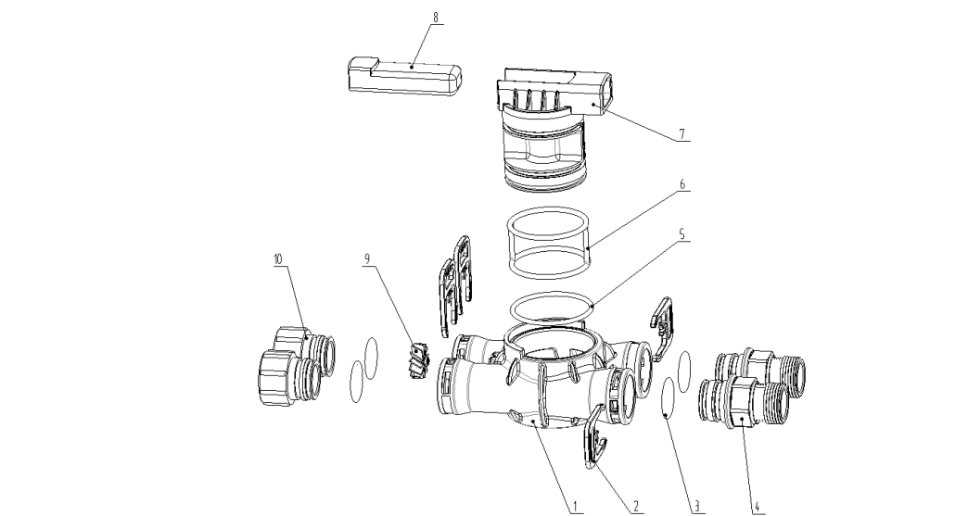
Bypass Components
Item No. | Description | Part # | Quantity
1 | Valve Body | 8022154 | 1
2 | Clip | 8270004 | 4
3 | O-ring 28X2.65 | 8378081 | 4
4 | NPT Connector | 8458065 | 2
5 | O-ring59.92x3.53 | 8378110 | 1
6 | Seal Ring | 8370007 | 1
7 | Spool | 8259003 | 1
8 | Handle | 8253051 | 1
9 | Impeller | 5295003 | 1
10 | Animated Connector | 8945001 | 2

RevV4 Valve Components
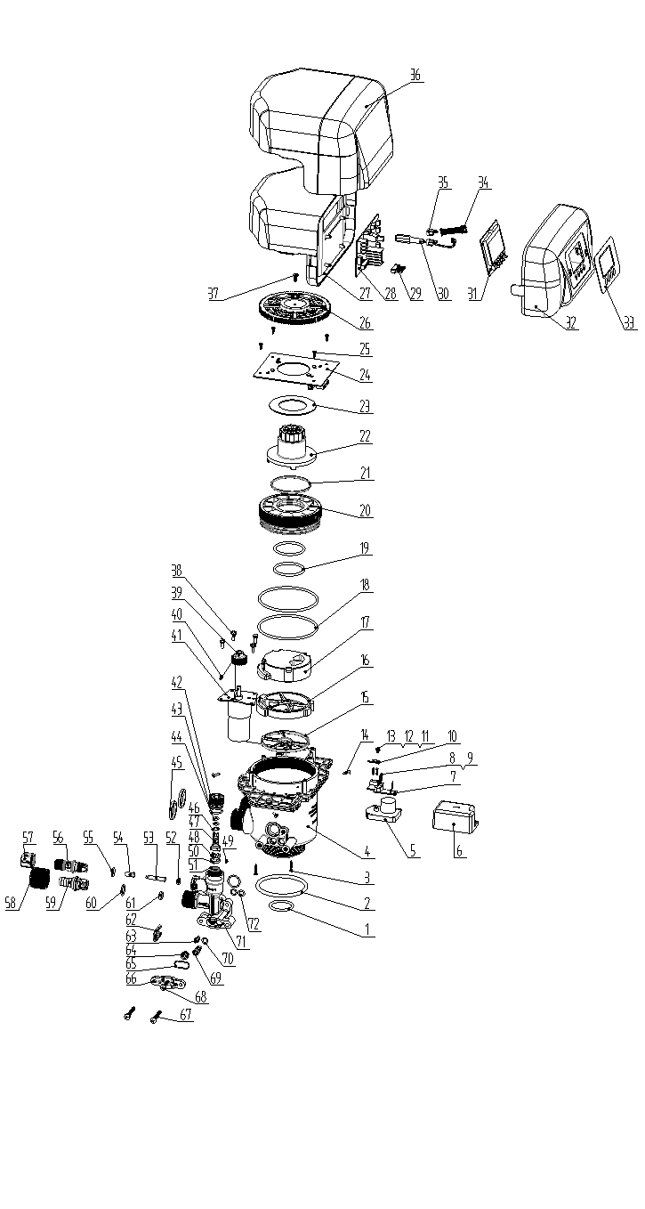

Item No. | Description | Part # |  | Quantity
1 | O-ring32.5X3.55 | 8378116 |  | 1
2 | O-ring73x5.3 | 8378143 |  | 1
3 | Screw, Cross ST2.9X16 | 8909010 |  | 2
4 | Valve Body | 8022742 |  | 1
5 | Motor | 6158052 |  | 1
6 | Dust Cover | 8005034 |  | 1
7 | Control Board | 6382025 |  | 1
8 | Screw, Cross M2X10 | 8902035 |  | 4
9 | Spring Washer 2 | 8953007 |  | 4
10 | Pick | 8152017 |  | 1
11 | Washer | 8952008 |  | 1
12 | Spring Washer | 8953008 |  | 1
13 | Screw, Cross M3X6 | 8902034 |  | 1
14 | Screw, Cross ST2.9X13 | 8909009 |  | 4
15 | Seal Ring | 8370075 |  | 1
16 | Fixed Disk | 8469048 |  | 1
17 | Moving Disk | 8459050 |  | 1
18 | O-ring 90x3.55 | 8378180 |  | 2
19 | O-ring 43.7x3.55 | 8378123 |  | 2
20 | Fitting Nut | 8092033 |  | 1
21 | Moving Seal Ring | 8370065 |  | 1
22 | Shaft | 8258014 |  | 1
23 | Anti-friction Washer | 8216012 |  | 1
24 | Locating Board | 6378007 |  | 1
25 | Screw, Cross ST2.9X9.5 | 8909008 |  | 4
26 | Gear | 8241017 |  | 1
27 | Dust Cover | 8005033 |  | 1
28 | Control Board | 6382022 |  | 1
29 | Wiring of Locating Board |  | 5511014 | 1
30 | Wire for power |  | 8513001 | 1
31 | Display Board |  | 6381006 | 1
32 | Front Cover |  | 8300030 | 1
33 | Label |  | 8865040 | 1
34 | Wire for Display Board |  | 5512002 | 1
35 | Cable Clip |  | 8126004 | 2
36 | Weather Cover |  | 8300031 | 1
37 | Screw, Cross ST3.9X13 |  | 8909013 | 1
Item No. | Description |  | Part # | Quantity
38 | Screw, Cross M4×12 |  | 8902005 | 4
39 | Small Gear |  | 8241019 | 1
40 | Pin |  | 8993003 | 1
41 | Motor |  | 6158012 | 1
42 | Fitting Nut |  | 8092034 | 1
43 | O-ring 17.5x2 |  | 8378182 | 2
44 | O-ring 6.08x1.78 |  | 8378155 | 2
45 | Seal Ring 30OD X 24ID X 3.3 |  | 8371001 | 2
46 | Anti-friction Washer |  | 8216013 | 1
47 | Valve Rod |  | 8206012 | 1
48 | Moving Disk |  | 8459034 | 1
49 | Screw, Cross ST2.2X6.5 |  | 8909004 | 3
50 | Fixed Disk |  | 8469050 | 1
51 | Seal Ring |  | 8370054 | 1
52 | Brine Line Flow Control |  | 8468052-8468057 | 1
53 | Filter Screen |  | 8336008 | 1
54 | Tube |  | 8457039 | 1
55 | O-ring 11x2 |  | 8378169 | 1
56 | Connector |  | 8458068 | 1
57 | Hexagonal Nut |  | 8940001 | 1
58 | Articulated Nut |  | 8945025 | 1
59 | Connector |  | 8458064 | 1
60 | O-ring 15x1.8 |  | 8378179 | 1
61 | Drain Line Flow Control |  | 8468042-4468045 | 1
62 | Clip |  | 8270010 | 1
63 | Tube |  | 8467001-8467010 | 1
64 | Injector Nozzle |  | 8454001-8454010 | 1
65 | O-ring 17x1.8 |  | 8378148 | 1
66 | Injector Cover |  | 8315003 | 1
67 | Screw, Cross M5X35 |  | 8902017 | 2
68 | Screw, Cross M5X23 |  | 8902015 | 1
69 | Filter Screen |  | 5336008 | 1
70 | O-ring 7x1.8 |  | 8378015 | 1
71 | Injector Body |  | 8008008 | 1
72 | O-ring 7.5x1.8 |  | 8378016 | 2

